Day 5 SQL Assignment

1.      GROUP BY with WHERE - Orders by Year and Quarter

Display, order year, quarter, order count, avg freight cost only for those orders where freight cost > 100

SELECT

EXTRACT(YEAR FROM order_date) as year,

EXTRACT(QUARTER FROM order_date) as quarter,

count(*) as order_count, AVG(freight) as frieght_cost

FROM orders

WHERE freight > 100

GROUP BY EXTRACT(YEAR FROM order_date),

EXTRACT(QUARTER FROM order_date);

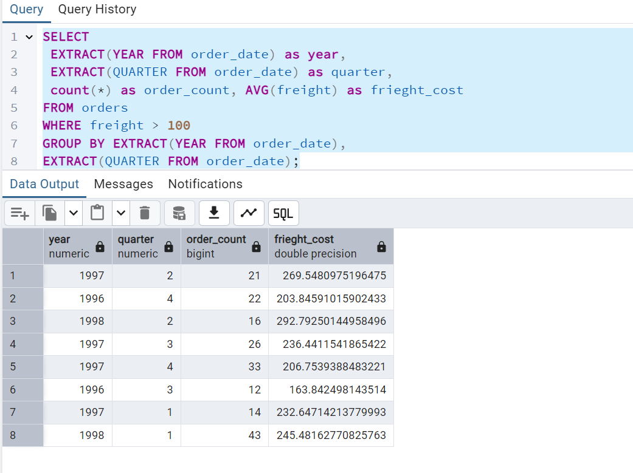

2.      GROUP BY with HAVING - High Volume Ship Regions

Display, ship region, no of orders in each region, min and max freight cost  
 Filter regions where no of orders >= 5

SELECT

ship_region, count(ship_region) as no_of_orders,

MIN(freight) as min_freight,

MAX(freight) as max_freight

FROM orders

GROUP BY ship_region

HAVING count(ship_region) >= 5;

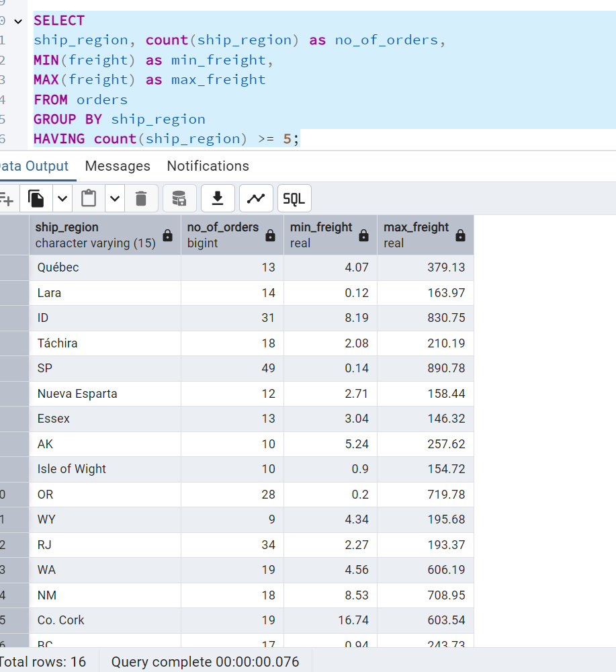

3.      Get all title designations across employees and customers ( Try UNION & UNION ALL)

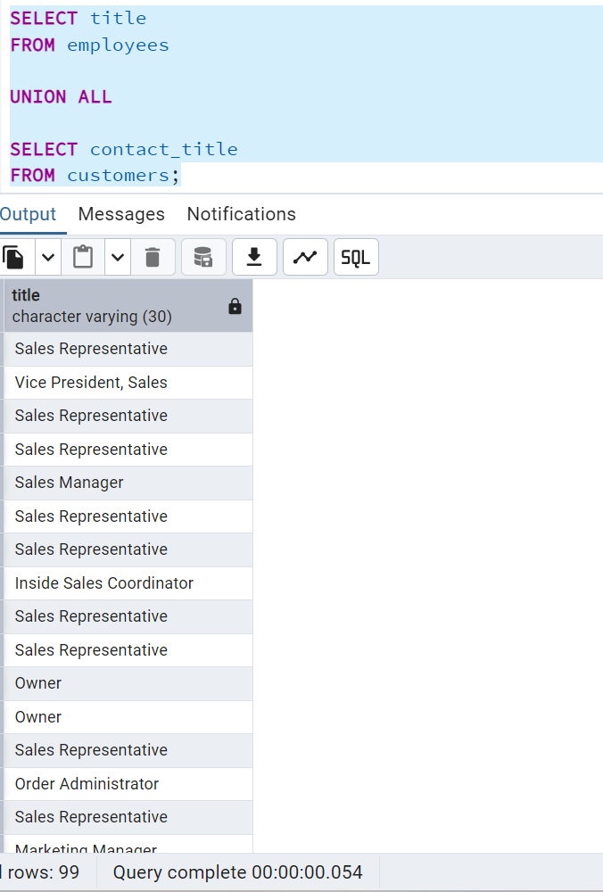

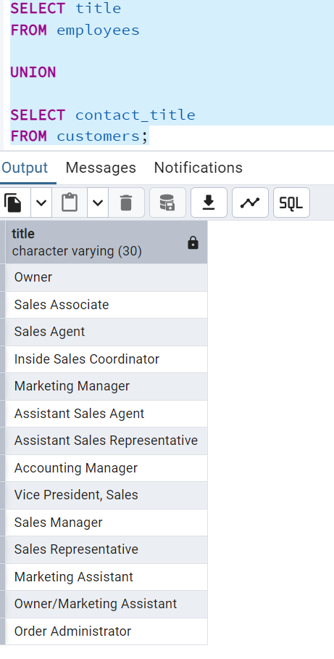

4.      Find categories that have both discontinued and in-stock products

(Display category_id, instock means units_in_stock > 0, Intersect)

SELECT category_id

FROM categories

INTERSECT

SELECT category_id

FROM products

WHERE units_in_stock > 0

AND discontinued = 1;

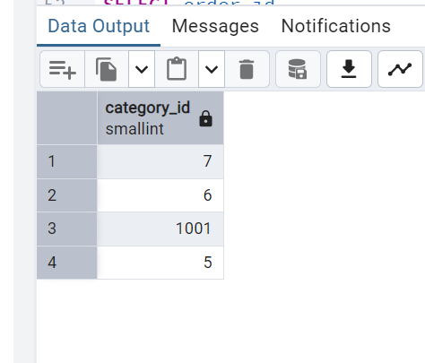

5.      Find orders that have no discounted items (Display the  order_id, EXCEPT)

SELECT order_id

FROM orders

EXCEPT

SELECT order_id

FROM order_details

WHERE discount = 0;

